1. Launch one AWS EC2 instance and install Jenkins.
Step 1:- Log in to the AWS Console, open EC2, and click on Launch Instance
Step 2:- Select Ubuntu as the AMI, t2.medium as the instance type, and create a key pair
Step 3:- Allow SSH (port 22) and port 8080 in the Security Group, then click on Launch Instance
Step 4:- Connect to the server and update the package list using sudo apt update
Step 5:- Install Java using sudo apt install fontconfig openjdk-17-jre -y
Step 6:- Add the Jenkins repository and key (from pkg.jenkins.io), then install Jenkins using sudo apt install jenkins -y
Step 7:- Start and enable Jenkins using sudo systemctl start jenkins and sudo systemctl enable jenkins
Step 8:- Open http://<server-public-IP>:8080 in the browser
Step 9:- Get the admin password using sudo cat /var/lib/jenkins/secrets/initialAdminPassword, paste it on the Unlock Jenkins page, install suggested plugins, and create the admin user

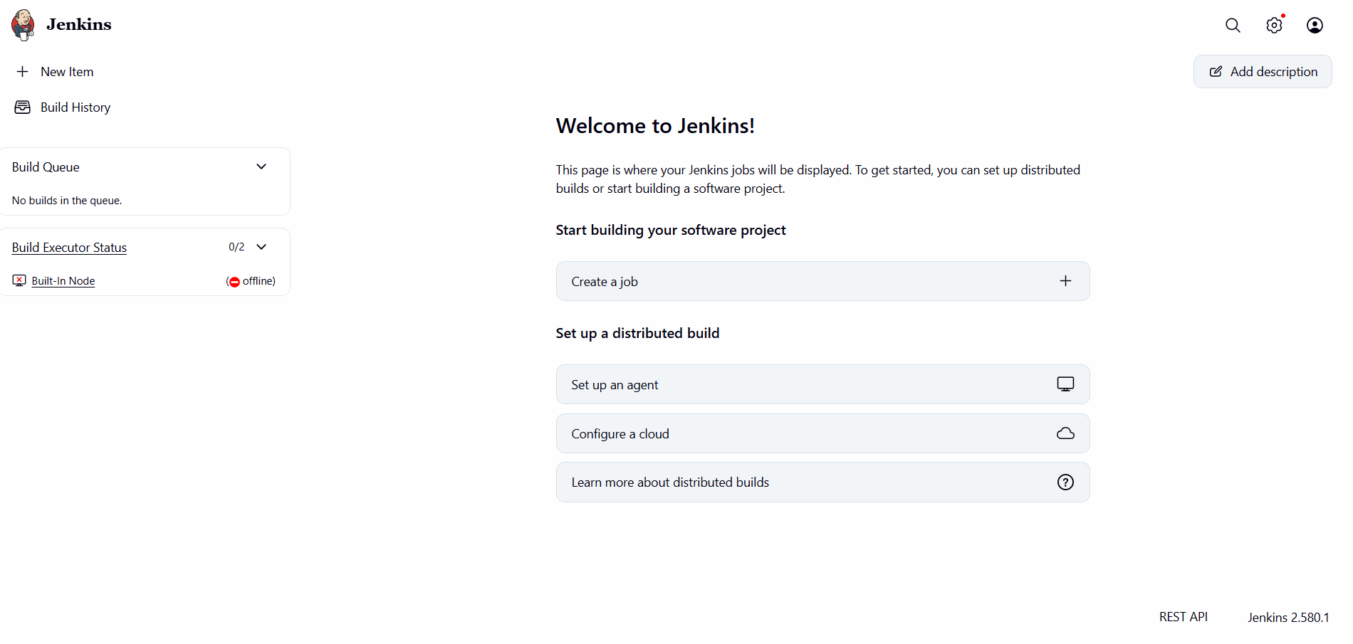

2. Setup Apache Tomcat on Ubuntu Virtual Machine.
Step 1:- Open the terminal of the Ubuntu VM and update the package list using sudo apt update
Step 2:- Install Java using sudo apt install openjdk-17-jdk -y, because Tomcat needs Java to run
Step 3:- Check the Java installation using java -version
Step 4:- Download the Tomcat tar.gz package from the official Apache Tomcat website using the wget command
Step 5:- Create a folder for Tomcat using sudo mkdir /opt/tomcat and extract the package into it using sudo tar -xzf <package-name>.tar.gz -C /opt/tomcat --strip-components=1
Step 6:- Give execute permission to the scripts using sudo chmod +x /opt/tomcat/bin/*.sh
Step 7:- Start Tomcat using sudo /opt/tomcat/bin/startup.sh
Step 8:- Check that Tomcat is running using ps -ef | grep tomcat
Step 9:- Open http://<VM-IP-address>:8080 in the browser to see the Tomcat home page (allow port 8080 in the firewall if the page does not open)
Step 10:- To stop Tomcat, use sudo /opt/tomcat/bin/shutdown.sh

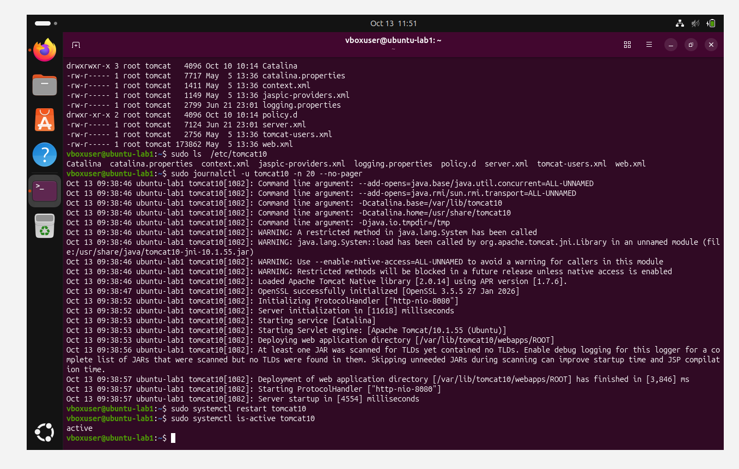

3. Setup Docker Desktop on your local Windows.
Step 1:- Check the system requirements: Windows 10 or 11 (64-bit), at least 4 GB RAM, and virtualization enabled in the BIOS
Step 2:- Open PowerShell as Administrator and run wsl --install to enable WSL 2, which Docker Desktop uses as its backend, then restart the computer if asked
Step 3:- Open the official Docker website (docker.com) and download Docker Desktop for Windows
Step 4:- Run the downloaded installer (Docker Desktop Installer.exe) and keep the option Use WSL 2 instead of Hyper-V selected
Step 5:- Click on OK and wait for the installation to finish, then click on Close and restart to restart the computer
Step 6:- Open Docker Desktop from the Start menu, accept the service agreement, and wait until the Docker engine status shows Running
Step 7:- Open PowerShell or Command Prompt and check the installation using docker --version
Step 8:- Test Docker by running docker run hello-world, which downloads a small test image and prints a success message
Step 9:- This way Docker Desktop is set up on Windows and we can start creating and running containers

